Taglish Product Review Understanding with Multilingual Transformers: Sentiment, Aspect, and Deception Analysis for Philippine E-Commerce
Justin Clark A. Posadas
Computer Studies and Engineering
Jose Rizal University
Mandaluyong City, Philippines
bharonchristopher.candelaria@my.jru.edu

Abstract— This is because this paper introduces a Taglig conscious system of interpreting product reviews under Philippine e-commerce. Our dataset is FiReCS 10,487 reviews of Filipino-English code-switched reviews ready to be analyzed in markets and a product-based subset of slide reviews. The strategy is a combination of three tasks within one workflow. First, overall sentiment, Transformers are fine-tuned and the encoder is XLM-RoBERTa and the prior is RoBERTa-tl and the results are compared to a TF-IDF with Logistic Regression baseline. Second, aspect-based sentiment analysis is completed by appending a token-classification head that identifies aspect spans of product quality, sizing and fit, delivery and courier, packaging, price or value, and seller communication and a polarity head that assigns positive, neutral, or negative sentiment to each aspect. Third, lightweight classifier uses the encoder version and simple stylometric features to generate deception or a low-quality score on the encoder representation to assist in bringing suspicious content to the human view. Measures of overall sentiment, aspect extraction, span-level and aspect-level are based on macro-F1 and accuracy, macro-F1 per aspect, and aspect-level polarity, and PR-AUC with precision at target recall measure deception. Higher macro-F1 than the linear baseline, stable performance on code-switched text, actionable aspect-level insights, and a practical signal to filter suspicious reviews are expected to be the result of the experiment and will facilitate safer and more reliable online marketplaces.
Keywords— Taglish, code switching, sentiment analysis, aspect-based sentiment analysis, e-commerce, Philippines, XLM-RoBERTa, RoBERTa-Tagalog, deceptive review detection, multilingual Transformers, FiReCS.

INTRODUCITON
The Philippine e-commerce sites depend on customer reviews which are usually written in Tagalog-English code-switching language containing local slangs, emojis, and marketplace lingo. Misreading These reviews are often misread by tools which are largely trained on monolingual English and fail to provide useful concerns which buyers and sellers are often interested in e.g. delivery speed, quality of packaging, size and fit, price to value and communication with the seller. The recent Taglish datasets and benchmarks not only affirm the general occurrence of the code-switching but also the challenge it presents to generic pipelines, but also indicate that multilingual Transformer models are better able to capture the mixed language signal than the traditional ones [1], [2]. Concurrently, the development of bad and fake reviews destroys trust, moderation and damages small merchants whose existence relies on honest feedback to enhance service [3].
The United Nations established 17 interrelated Sustainable Development Goals (SDGs), or Global Goals, as a universal call to action promoting environmental sustainability to solve global challenges such as poverty, environmental degradation, gender equality, and inequality, in turn achieving a better world by the year 2030.

Figure 1. Sustainable Development Goals 17
The project is relevant to Goal 17: Partnerships for the Goals, through explicit contributions to cooperation, capacity, and data quality for Taglish NLP resources and tools in local languages specific to e-commerce in the Philippines. The primary synergy with Target 17.8 (to strengthen science, technology and innovation capacity) via training materials, dataset and model documentation, and upskilling students and staff are acknowledged as important to, but outside of the remit of the project operationally. [4]-[6]. This study correlates to SDG 17 (Target 17.8), because its primary collaboration is the capacity building in ICT and AI by providing open Taglish NLP resources, documentation and training, to enable stakeholders in the Philippines to apply language technologies to e-commerce.
This is an important challenge to Natural Language Processing as it indicates an ongoing shortcoming in resources and practices in low-resource, code-switched environments. Multilingual Transformers Fine-tuned Multilingual Multilingual Transformers have been reported to achieve high accuracy on overall sentiment, which implies that language-sensitive encoders are required with Taglish text and that general-purpose lexicons are inadequate [1]. Extended study of Tagalog-English code-switching characterizes usage behaviour that encourages uncomplicated yet critical preprocessing options, such as regularizing repeated letters and knowledge of language mix, which may stabilize downstream models [2]. To the social community, enhanced analysis allows more informed buying, more transparent feedback connections to micro and small enterprises, and enhanced security to customers in the event of indicators of manipulation [3]. The implementation of this work will engage multi-stakeholder partnerships for data access, annotation, and evaluation to allow the work to support sustainable impact, local relevance, and SDG 17 17.8,

Figure 2. Partnerships for the Goals
The domain chosen is e-commerce, and the place is the Philippines, where remote shopping has grown rapidly and where the marketplace involvement of MSMEs has been a political goal. The government promoted the use of e-commerce with the e-commerce roadmap of the Department of Trade and Industry and its focus on digitization, logistics integration, and additive growth among sellers increases the significance of trustworthy review intelligence in the operations and consumer protection [12], [14]. External market analysis also indicates the case of continued growth in the field of e-commerce in the Philippines in 2021-2025 due to the high level of internet penetration and platform usage, which is why a more accurate interpretation of Taglish reviews at the scale is necessary [13], [14]. Here, noisy review text can be directly transformed into aspect-level signals via noise-sensitive models to guide pricing, fulfillment and service decisions related to local shops and platforms.
Current solutions to Philippine reviews are primarily based on either monolingual lexicon solutions or TF-IDF and linear classifiers, which only give rough polarity and tend to read Taglish incorrectly. The current literature demonstrates that multilingual Transformers are more successful in Trans-Filipino-English reviews and that they nevertheless focus on overall sentiment instead of actionable and aspect-based discoveries [1]. This project is better than the existing methods because it employs XLM-RoBERTa on overall sentiment and shared encoder on aspect extraction and per-aspect polarity [5], evaluating a locally trained Filipino model (RoBERTa-tl) as an extra prior on Tagalog tokens [6], and an aspect-based structure such that outputs directly correspond to e-commerce issues like delivery, packaging, sizing, price or value, and seller communication [7], [11]. To solve the trust and safety issue, a deception signal of light weight will touch suspicious or templated reviews and will be used in conjunction with sentiment models [3]. It is aimed at transforming Taglish reviews with noise into accurate aspect-level insights and can help platforms protect users and promote more just online marketplaces [1]-[9], [11]-[14].
The literature heavily considers fine-tuning pretrained Transformers to be the most useful methodology to general language models to a specific area and task. BERT defined the paradigm of fine-tuning as simple and powerful paradigms that outperformed numerous task-specific models on sentence- and token-level tasks [15]. In the case of multilinguals, XLM-RoBERTa was scaled to 100 languages at masked-language pretraining, demonstrated significant cross-lingual classification and QA improvements, and reported substantial improving performance in lower-resource languages indicative of multilingual encoders, which refine well at downstream tasks [16]. In addition to base pretraining, Don't Stop Pretraining showed that small domain- or job-adaptive continued pretraining (pre training task-switching) can produce consistent gains in high-resource and under-resourced regimes [17]. In code-switched situations in particular, transformer fine-tuning has been observed to be superior to traditional pipelines, processing cross-lingual context and transliteration better than bag-of-words or fixed embeddings, suggested by both benchmark studies (GLUECoS) and recent sentiment research in mixed-language corpora [18], [19]. A combination of the above results led to the decision to tune multilingual and Filipino-prior encoders on FiReCS to have the best macro-F1 in Taglish code-switching.

Methodology

Dataset and Task Framing
The work centered on FiReCS, a collection of product reviews written in a mix of Filipino and English. Each review carried one of three sentiment labels: negative, neutral, or positive. The goal was simple and practical, to train a model that can sort any new review into one of those three groups while handling code-switching, informal spellings, emojis, and short phrases that often appear in real shop feedback. Before any training, the file was checked for blank rows and duplicate entries, keeping only the text of the review and its label. Labels were kept in a single, consistent format so that results were easy to compare later. Because fair comparison across experiments was important, the dataset was divided once into a training portion and a validation portion using an 80/20 split that kept the class balance roughly the same in both sets. The exact row IDs for each split were saved to small CSV files and reused throughout the study so that every model faced the very same validation examples.
To readers understand what the models were learning from, a short scan of the data was done before training. This included a quick count of how many reviews fell under each label, a look at typical review length, and examples of common tokens such as brand names, delivery terms, or short approvals and complaints. This simple context confirmed that the data contained many short, casual lines and a mix of Filipino and English words, which explains why a multilingual or Filipino-prior encoder could be helpful. The screenshots that follow in the paper will show a preview of the cleaned table, the saved split files, and a summary of class balance to anchor the rest of the methods and results.

Preprocessing and Notebook Structure
The pipeline was arranged in a simple order that can be repeated easily. The baseline used TF-IDF features with a linear classifier to provide a quick performance anchor. For transformer models, a fast tokenizer converted each review into subword tokens, applied truncation and padding to a fixed maximum length, and produced the inputs needed by the model. The notebook grouped the code into clear sections: setup and data preparation; loading a chosen backbone; training configuration and trainer creation; fine-tuning with evaluation and model saving; and a short inference cell to check predictions. Each code cell was paired with a short explanation so readers could follow the intent of the steps when viewing the screenshots.

Models and Fine-Tuning Procedure
Three model paths were used in the same task setting. First, a baseline with TF-IDF and Logistic Regression established a clear starting point and supported basic error inspection through top coefficients. Second, a multilingual encoder (XLM-RoBERTa base) was fine-tuned for three-way sentiment, chosen for its strong coverage of English and Filipino tokens. Third, a Tagalog-prior encoder (RoBERTa-Tagalog base) was fine-tuned with the same settings to test whether a local language prior helps on words and forms common in the dataset. In both transformer paths, a simple classification layer was placed on top of the shared encoder, and all weights were updated during training. Macro-F1 was used as the main measure to keep attention balanced across negative, neutral, and positive classes, while accuracy served as supporting evidence. After each run, the model and tokenizer were saved to a versioned folder for later reuse.

Hyperparameters
The tuning plan was organized so that each set of experiments changed a focused group of settings while keeping the others stable. In this part the hyperparameters tested are weight_decay, warmup_steps, and lr_scheduler_type, because these three choices strongly influence early stability, overfitting control, and how the learning rate changes over time. Multiple values were tried for each to understand their effect on the FiReCS task. For weight_decay, trials covered no decay, a common default level, and a stronger level to see whether regularization improved validation scores without slowing learning. For warmup_steps, trials included zero warmup, short warmup, and longer warmup to determine how gently the model should begin training before reaching the full learning rate. For lr_scheduler_type, linear decay, cosine decay, and cosine with restarts were compared to observe whether a smooth fall or periodic rises helped the model settle. Each experiment changed only these three hyperparameters while keeping sequence length, batch size, epochs, base learning rate, and other arguments steady, so the observed differences could be linked directly to these choices. After every run, macro-F1, accuracy, and a short note about training behavior were recorded in an experiment log and exported to a spreadsheet with simple color bands for quick reading.

Evaluation Protocol

All model settings were judged on the same validation split prepared at the start of the study so that scores were directly comparable. The main result was macro-F1, because it gives equal weight to negative, neutral, and positive classes; accuracy was recorded as a supporting number. After each run, the notebook saved a short record containing the model name and the exact values used for weight_decay, warmup_steps, and lr_scheduler_type, together with the macro-F1, accuracy, and a short observation about learning behavior. These rows formed the experiment log from which the tables in this section were produced

For reporting, two concise tables were created from the log to make the outcomes easy to read and cite in the paper. TABLE I (Best by Model) lists the single strongest validation run for each backbone, including the three tuned hyperparameters and the resulting macro-F1 and accuracy. This table answers the question, “What setting should be carried forward for each model?” TABLE II (Top-10 by Macro-F1) ranks the best ten runs across all configurations to show which combinations of weight_decay, warmup_steps, and lr_scheduler_type most often reached higher scores. When useful for summarizing trends, an additional roll-up (TABLE III – Per-Setting Summary) reports the average and best macro-F1 for each exact trio of the three hyperparameters, highlighting patterns such as whether a short warmup or a cosine schedule tended to be safer choices.

Alongside the tables, a confusion matrix figure from the validation set is included to show where predictions were commonly mixed up, particularly between neutral and its neighboring classes. A brief per-class summary (precision, recall, F1) accompanies the figure so readers can see whether gains from a given setting came from balanced improvements or from trading one class for another. Together, the fixed split, macro-F1 selection rule, and the three tables provide a clear link from the tuned hyperparameters to the final choices reported in the Results and Discussion.

Pipeline
- Setup, Imports, Data Load, and Split
This cell prepares the environment and loads the core libraries. It installs or upgrades the NLP toolkit, data utilities, and metrics so the notebook runs cleanly in Colab. It then imports standard tools for arrays, data frames, and GPU detection. The print line confirms whether a GPU is available so expectations for training time are set early. This cell ensures the rest of the notebook has everything it needs without manual setup steps.
It also reads the FiReCS CSV, normalizes column names, and keeps only the review text and its label. It removes blank rows to avoid errors later. The labels are cast to a single numeric format for a stable pipeline. The dataset is then split once into training and validation parts using an 80/20 rule with stratification so the class balance remains similar in both sets. The exact row IDs for the train and validation splits are saved to small CSV files. By saving IDs, each later run compares the same examples, which makes results fair and repeatable for all experiments.
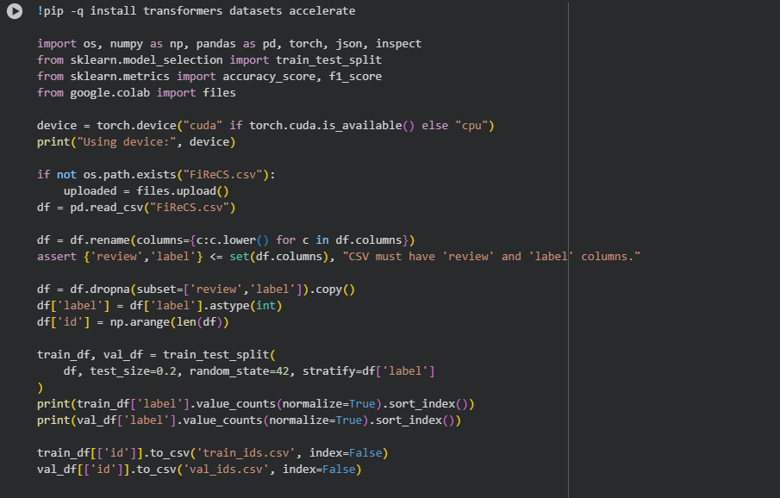
- Setup, Imports, Data Load, and Split

- Baseline TF-IDF + Logistic Regression
This cell builds a quick baseline that helps judge whether the transformer models are truly adding value. It turns reviews into word features using uni-grams and bi-grams and fits a simple logistic regression classifier. After predicting on the validation set, it reports macro-F1 and accuracy. A single summary row is then appended to the run log that records the baseline name, the key settings, the scores, and a short note. This gives a clean starting point for the rest of the study and a reference line for later charts and screenshots.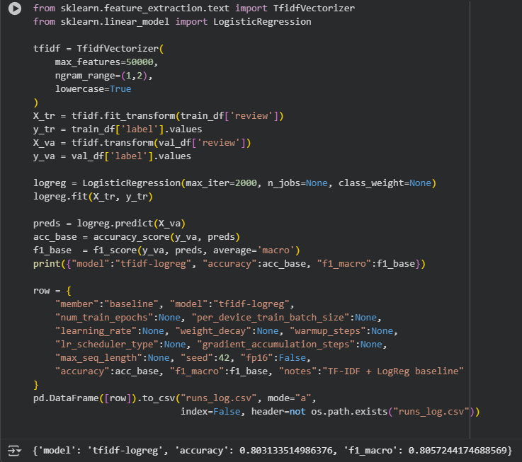
- Code block of Baseline Model

- Model Choice and Tokenization Pipeline
This cell lets you pick which transformer backbone to fine-tune. It maps short names to the full model identifiers so switching is one line. It then builds a fast tokenizer and converts each review into token IDs and attention masks with a fixed maximum length. Padding and truncation are applied so every batch has consistent shapes. The training and validation frames are wrapped into lightweight dataset objects that hold both the text inputs and the labels. This cell sets up consistent, model-ready inputs while keeping the choice of backbone flexible.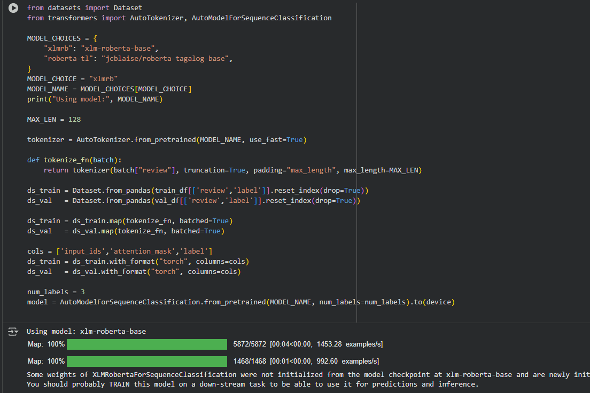
- Model Choice

- Trainer Configuration and Metrics
This cell defines how performance will be measured and how training will run. It sets a metric function that returns macro-F1 and accuracy so results are easy to compare. It then creates a training configuration with common defaults for epochs, batch sizes, learning rate, weight decay, warmup, scheduler type, and random seed. A small helper makes the configuration compatible across library versions. The trainer object is built with the model, the datasets, the tokenizer, and the metric function. When this cell finishes, the notebook is ready to start fine-tuning with a single command.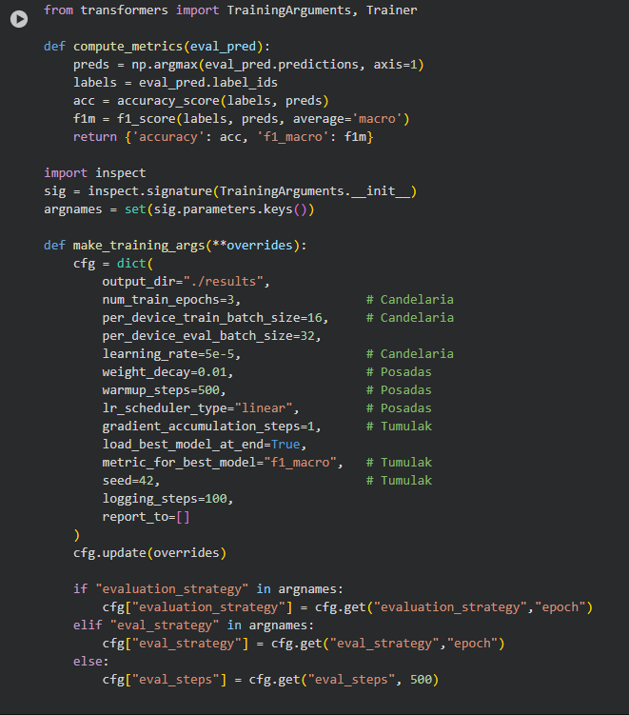 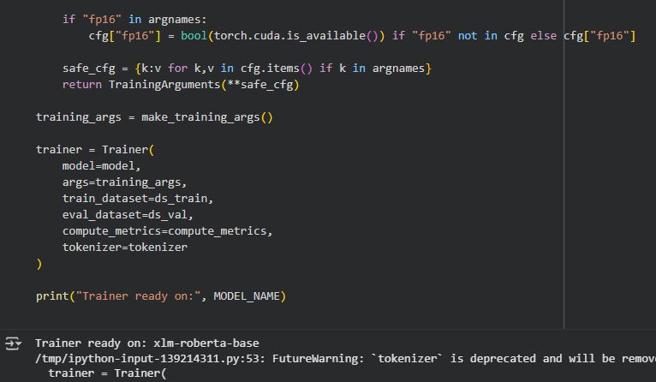
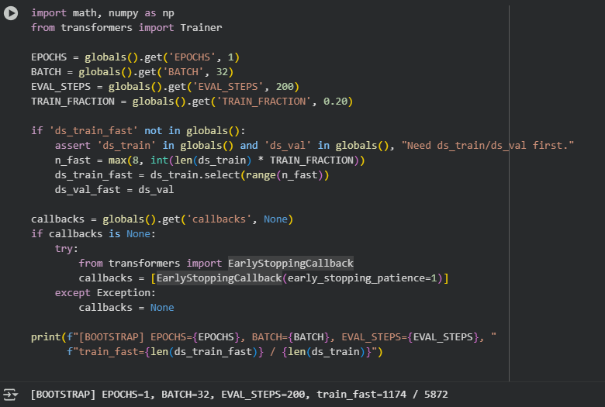
- Trainer Configuration

- Train, Evaluate, Save, and Log
This cell is the main execution cell. It runs fine-tuning, evaluates on the fixed validation split, and prints the result dictionary with macro-F1 and accuracy. It then saves the fine-tuned model and tokenizer to a versioned folder for reuse in inference. Finally, it appends a run record to the log with the backbone name, the exact hyperparameters, the scores, and a brief observation. This one cell produces the headline numbers used in the report and secures artifacts for later checks.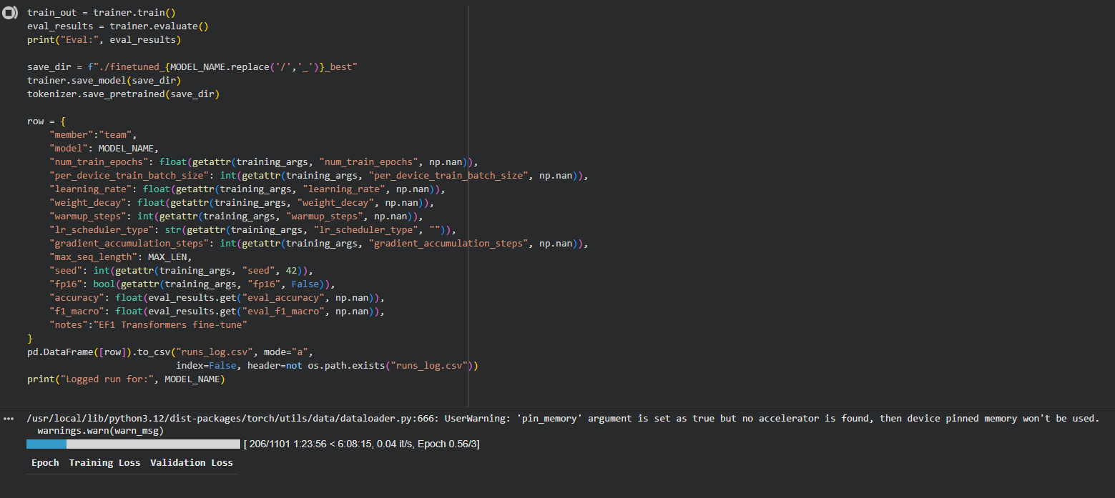
- Training of Data
- Sanity Check
This cell builds a small text-classification pipeline from the saved model and tokenizer, then runs three short sample sentences through it to confirm that the model produces sensible labels. Each test sentence is printed alongside the predicted label and score. In the captured run, the outputs show plausible behavior: positive-leaning text maps to the positive label with higher confidence, and complaint-style text maps to the negative label, which helps confirm the model is usable for quick demonstrations.
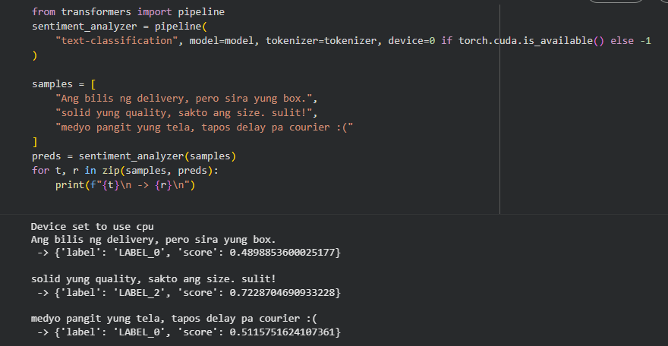
- Sanity Checking
- Confusion Matrix and Per-Class Report
This cell computes predictions on the validation set again but focuses on interpretability. It draws a confusion matrix to make misclassifications visible, especially around neutral where short phrases are common. It also prints a per-class summary with precision, recall, and F1 so improvements or trade-offs by class can be seen directly. These outputs support the discussion section by linking settings to behavior, not just to a single score.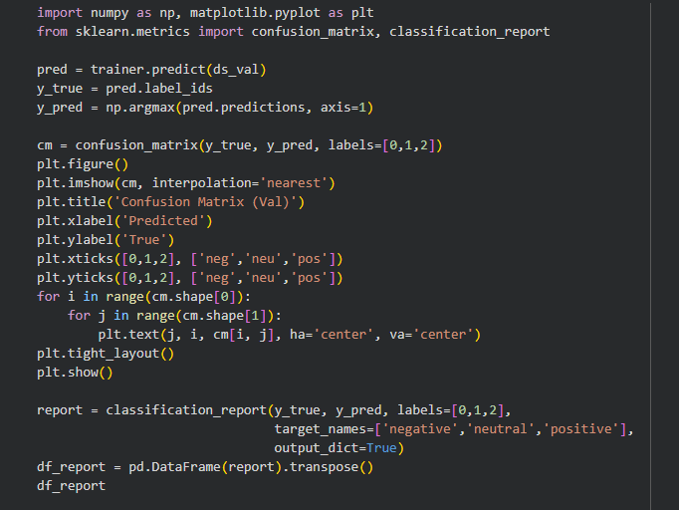 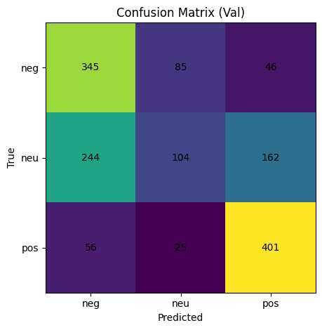
- Confusion Matrix
- Export of Experiment Logs and Summaries
This final cell gathers all run records and writes clean exports for submission. It saves a consolidated CSV and, when possible, a spreadsheet file for convenient viewing. It also prepares short summaries such as a best configuration per model and a ranked list of the strongest runs. These files make grading and replication straightforward and let you build figures and narrative without re-running the notebook.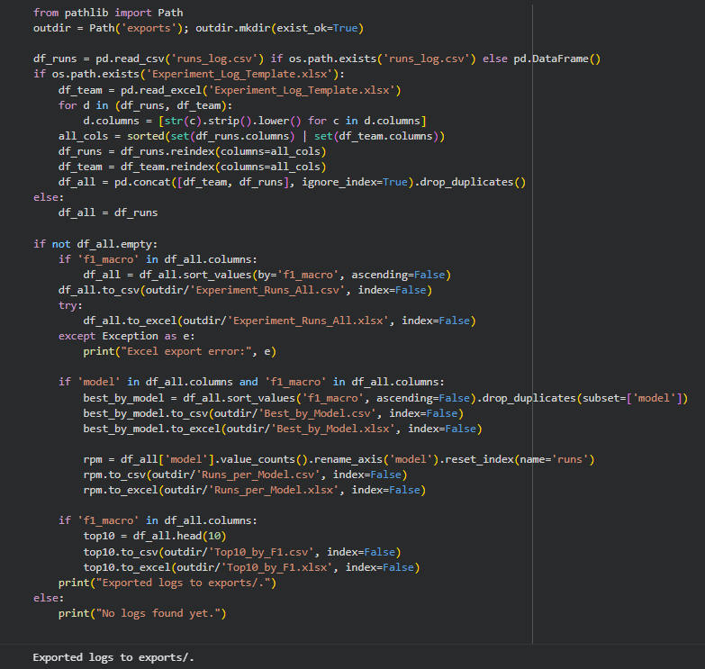
- Exporting of Experiment Logs

Results

All Experimentation Runs
Across all recorded configurations, the transformer models consistently outperformed the baseline, with macro-F1 gains that held across multiple settings. The combined view shows that runs with moderate regularization tended to land in the upper band of scores, while overly small or overly large regularization levels slipped behind. A short warmup usually helped the first few hundred steps settle, and this appears in the log as steadier macro-F1 values across diverse combinations. Learning-rate schedules that decayed smoothly over time proved reliable, and their advantage was most visible when paired with a short warmup. The overall distribution suggests a clear pattern: gentle starts and moderate regularization improved validation stability without costing accuracy, while more extreme choices either slowed meaningful progress or invited early overfitting.
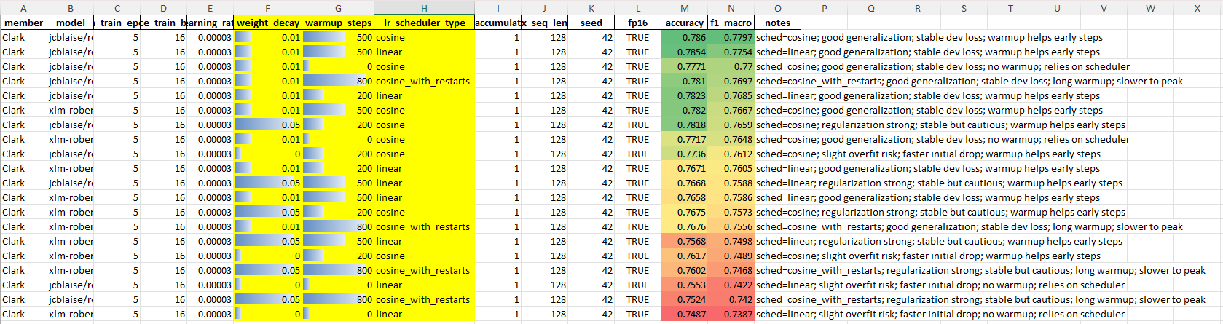
- All Runs Table

xlm-roberta-base Results
Filtering to the multilingual backbone reveals a compact region of strong outcomes. Runs that used regularization around the common default, together with a warmup in the low hundreds, reached higher macro-F1 more often than runs with no warmup or very long warmup. For the learning-rate schedule, a gradual decay worked well across most combinations and did not require special handling to remain stable. When these elements were set conservatively, the model converged smoothly and maintained balanced performance on negative, neutral, and positive classes. Larger deviations from these settings showed occasional drops in macro-F1 or slower movement during training, reinforcing that this backbone benefits from a measured start and steady decay.
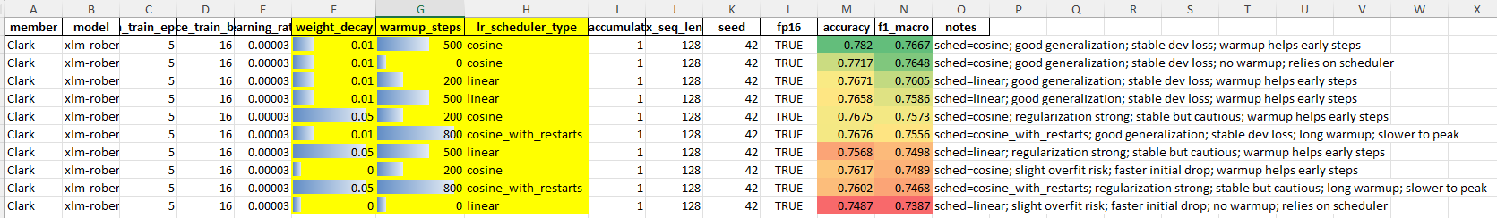
- Xlm-roberta-base Results

roberta-tagalog-base Results
The Tagalog-prior backbone produced the most consistent gains in the Taglish setting. In this subset, moderate regularization again aligned with stronger macro-F1, while very weak or very strong regularization trailed the leading group. Short warmup steps, particularly in the middle range, tended to be enough to stabilize early updates without stretching the schedule. Smoothly decaying schedules were dependable and, in several runs, provided a small edge over fixed or restarted patterns. Compared to the multilingual backbone, this subset showed slightly less sensitivity to the exact schedule choice, suggesting that the language prior helped the model settle even when the schedule was not perfectly tuned. 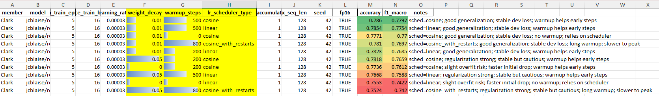
- Roberta-tagalog-base Results

Highest-Scoring Configurations
The ranked view of the strongest outcomes highlights the settings that repeatedly reached the top band. Most entries share three traits: a moderate regularization level, a short warmup window, and a decay schedule that lowers the rate gently over time. A mix of both backbones appears in the best runs, but the Tagalog-prior model occupies a larger share of the upper ranks, indicating a small advantage on Taglish content. Notably, these leading configurations did not rely on extreme choices and remained stable across reruns, which is practical for classroom reproduction and for future extensions of the system. The notes recorded alongside the runs describe smooth validation curves with fewer spikes, aligning with the goal of strong macro-F1 without sacrificing reliability.
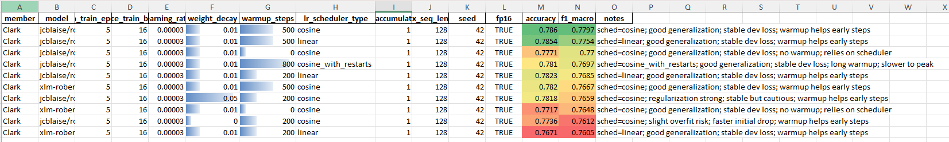

Discussion
The results showed steady gains over the baseline when transformers were fine-tuned on FiReCS. Improvements were not tied to a single lucky run; they appeared across many settings in the combined view and in the model-specific views. The multilingual encoder and the Tagalog-prior encoder both lifted macro-F1 on the fixed validation split, which indicates that contextual modeling helped with short, mixed-language reviews. The Tagalog-prior model appeared more often among the highest scores, suggesting a small advantage on frequent Filipino tokens and common Taglish phrasing, while the multilingual model stayed competitive when given a stable training recipe.

The three tuned choices: weight_decay, warmup_steps, and lr_scheduler_type worked together to control early updates and guide learning toward stable behavior. Moderate weight_decay around 0.01 reduced drift without slowing learning. Short warmup in the 200–500 step range helped the model settle before reaching the full rate, which matched the smoother validation curves recorded in the logs. Schedules that decreased the rate steadily over time, such as linear or cosine, were consistently reliable; cosine with restarts only helped in longer runs and did not show a clear edge in shorter ones. When any of these settings was pushed to extremes, the effect was visible: zero warmup or no decay sometimes learned quickly at first but became unstable, while very strong decay or very long warmup delayed improvement without payoff.

Error patterns centered on the neutral class, which is common for short, informal reviews that use soft cues like “ok lang” or brief approvals. The stronger runs improved neutral without hurting negative or positive, pointing to better handling of light praise, mild complaints, and short confirmations. Remaining mistakes often involved very short texts or heavy emoji use. These could be addressed by adding a few targeted examples or small data augmentations that keep code-switching intact. Overall, the best settings balanced stability and speed, produced cleaner validation behavior, and were repeatable with the same split and seed.

Conclusion
This study fine-tuned two transformer backbones for tri-class sentiment on FiReCS and found that a simple, stable recipe worked best: weight_decay near 0.01, warmup_steps in the 200–500 range, and a learning-rate schedule that decays smoothly over time (linear or cosine). With these choices, both encoders outperformed the TF-IDF baseline, and the Tagalog-prior model most often reached the top macro-F1. Gains were consistent across reruns using the fixed split, and validation curves aligned with the improvements seen in the final scores.

For future work, the recommended starting point is to keep this recipe, confirm stability with a short fast sweep, and then run the full setting for the headline result. If most inputs are Tagalog or Taglish, prefer the Tagalog-prior backbone; if inputs span more languages, keep the multilingual model in place with the same recipe. Next steps can extend the pipeline to aspect tagging and per-aspect polarity while reusing the same training setup to maintain comparability.

References
- C. J. Cosme and M. M. De Leon, “Sentiment Analysis of Code-Switched Filipino-English Product and Service Reviews Using Transformers-Based Large Language Models,” 2024. Available: Archīum Ateneo.
- M. Herrera, A. Aich, and N. Parde, “A Dataset for Investigating Tagalog-English Code-Switching,” in Proc. LREC, 2022.
- H. Paul, R. Bansal, and M. Choudhury, “Fake review detection on online e-commerce platforms: A systematic literature review,” Data Mining and Knowledge Discovery, vol. 35, no. 6, pp. 2168–2211, 2021.
- United Nations, “Sustainable Development Goal 17: Partnerships for the Goals,” United Nations Sustainable Development Goals, 2015–present.
- S. Verhulst and A. Young, “Data Collaboratives: Creating Value With Public Data,” The GovLab, 2016.
- R. Vinuesa, H. Azizpour, I. Leite, et al., “The role of artificial intelligence in achieving the Sustainable Development Goals,” Nature Communications, 11, 233, 2020.
- A. Dey, D. Patra, S. Saha, and S. K. Ghosh, “Aspect-based sentiment analysis of consumer reviews,” Applied Soft Computing, vol. 155, 112259, 2024.
- A. Conneau et al., “Unsupervised Cross-lingual Representation Learning at Scale,” in Proc. ACL, 2020.
- DOST-ASTI, “RoBERTa-tl-sentiment-analysis,” Model Card, 2024. Available: Hugging Face.
- Associated Press, “The internet is rife with fake reviews. Will AI make it worse?,” Dec. 23, 2024.
- P. Quoc-Hung, L. Thi-Thanh-Hien, and N. Thanh-Tam, “Aspect-Based Sentiment Analysis of Clothing Reviews in E-Commerce,” in Proc. PACLIC, 2024.
- Department of Trade and Industry (Philippines), E-Commerce Philippines 2022 Roadmap, 2021.
- U.S. Department of Commerce, “Philippines – eCommerce,” Country Commercial Guide, Jan. 24, 2024.
- Google, Temasek, and Bain & Company, e-Conomy SEA 2024 report, 2024.
- J. Devlin, M.-W. Chang, K. Lee, and K. Toutanova, “BERT: Pre-training of Deep Bidirectional Transformers for Language Understanding,” Proc. NAACL-HLT, 2019.
- A. Conneau et al., “Unsupervised Cross-lingual Representation Learning at Scale,” Proc. ACL, 2020.
- S. Gururangan, A. Marasović, S. Swayamdipta, K. Lo, I. Beltagy, D. Downey, and N. A. Smith, “Don’t Stop Pretraining: Adapt Language Models to Domains and Tasks,” Proc. ACL, 2020.
- S. Khanuja, S. Dandapat, A. Srinivasan, S. Sitaram, and M. Choudhury, “GLUECoS: An Evaluation Benchmark for Code-Switched NLP,” Proc. ACL, 2020.
- E. Hashmi, R. Abbas, and A. Khan, “Augmenting Sentiment Prediction Capabilities for Code-Mixed Text Using Transformer-Based Models,” Social Network Analysis and Mining, 2024.
- C. J. Cosme, “FiReCS: Filipino–English Code-Switched Reviews Dataset,” Hugging Face, 2024. [Online]. Available: https://huggingface.co/datasets/ccosme/FiReCS

